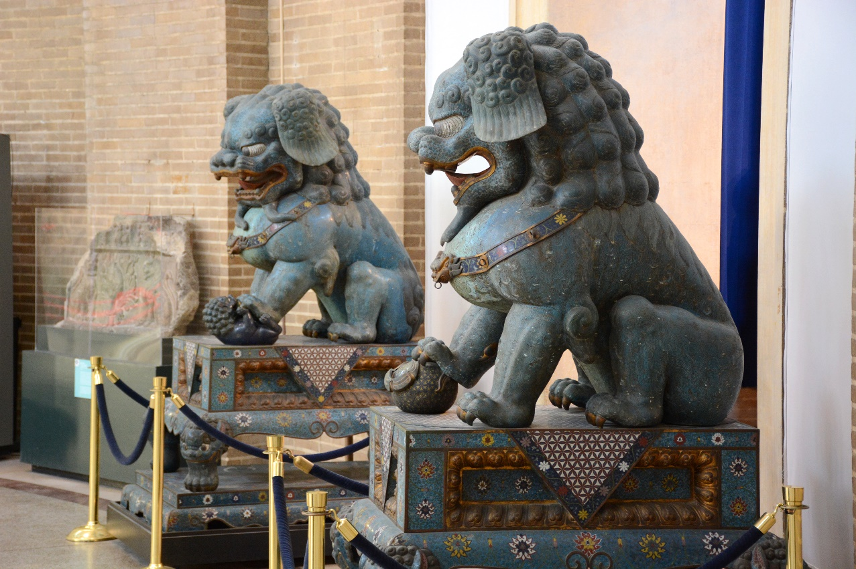 |  | Walk with the Animals
All Galleries |  | 50 minutes

Animals appear frequently in the art and material culture of many peoples around the world. This lesson relies on the ubiquity of animal motifs in art to teach students the names of commonly-depicted animals, their basic taxonomic relationships, and general biology. Students will experience a self-contained lesson covering the vocabulary of the natural world while enjoying a brief tour of the Museum’s galleries.

Vocabulary List

- Animals: bear, beaver, bull, butterfly, camel, cat, crocodile, deer, dog, duck, eagle, elephant, frog, horse, lion, pig, sheep, turtle
- Categories: bird, insect, reptile, mammal
- Descriptors: antenna, antlers, domesticated, feather, hair, hoof, horns, large, small, teeth, wild, wing

The Museum Visit

Explore the 2nd Floor Galleries (5-10 minutes)
Give the class a few minutes to explore the 2nd floor galleries (Africa, Mexico & Central America, and Native American Voices). Encourage students to identify animal figures and motifs.
Introductory Group Discussion (10 minutes)
Return to the Native American Voices gallery and gather in front of the wooden animal figures. Discuss the different types of animals seen so far. Why are those animals found associated with particular places and cultures? What predictions can be made about animals in other parts of the Museum? Possible questions include:
- What animals are most common?
- Are there any animals that are present among most/all of the cultures represented on the 2nd floor? If so, why?
- Are there any animals that seem to be underrepresented, or conspicuous in their absence?
- Are most depictions of domesticated or wild animals? Why?
- Some animals are depicted more realistically, while others are more stylized. Why is this, and does it depend on the culture, the animal, or both?

Explore the 3rd Floor Galleries (15 minutes)
Take the students up the main staircase to the 3rd floor to explore the Asian, Egyptian and Classical galleries on their own or in pairs. Instruct them to keep notes on the animals they find among the collection, and return to the Japan Gallery when they are finished.

Group Discussion (10 minutes)
Gathering in front of the shrine, lead the students in a discussion of the animals they found on the 3rd floor.

recommended objects

Native American Voices
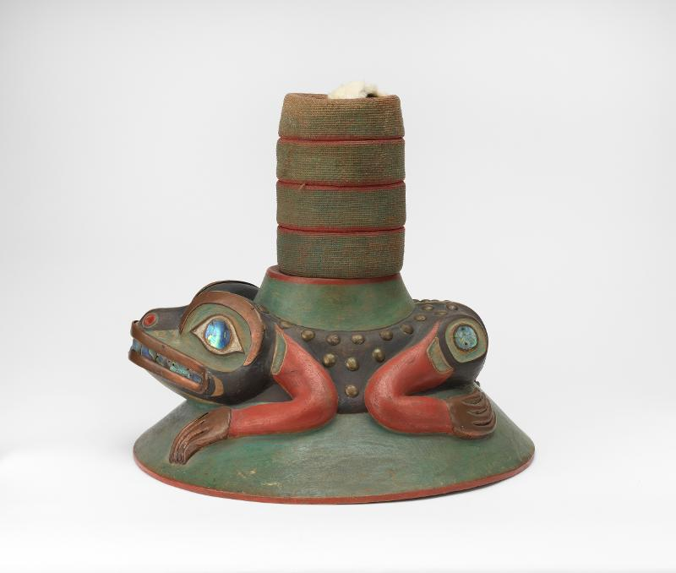

Frog Clan Hat (NA11740)

Bear Pipe Bowl (38377)

Duck Decoy (81-8-1)

Wolf Figure (40700E)

African Galleries

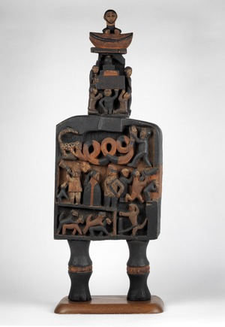

Wooden Sculpture (2003-48-35)

Crocodile Weight (AF2419)

Butterfly Weight (75-26-10)

Post-Visit Activities

Fantastic Beasts
During your tour of the galleries, you probably noticed that many cultures depict mythical animals in their art (for example, the Minotaur in Greece, or the dragons in China). With a partner, fold a sheet of paper in half and draw part of an animal on one side, then exchange with your partner to complete the drawing. When you are finished, open the paper and decide together on a name for your animal, as well as a short description of its habitat, diet, and behavior.

Become an Ancient Artist
Choose a type of animal and a culture that don’t occur together in the Museum’s galleries (for instance, bear and Ancient Egypt). Create your own work of art depicting the animal in the style of the culture you have chosen. Include with your drawing a description in which you explain your stylistic choices.

Questions?
Ready to schedule a visit?
Contact Penn Museum’s Academic Engagement Department at
classuse@pennmuseum.org

recommended objects

Classical Galleries

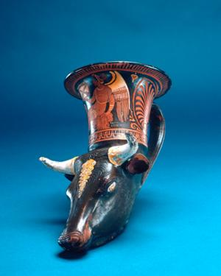

Bull Rhyton (L-64-227)

Votive Horse Figurine (48-2-115)

Wined Lion Statue (59-24-1)

China and Japan

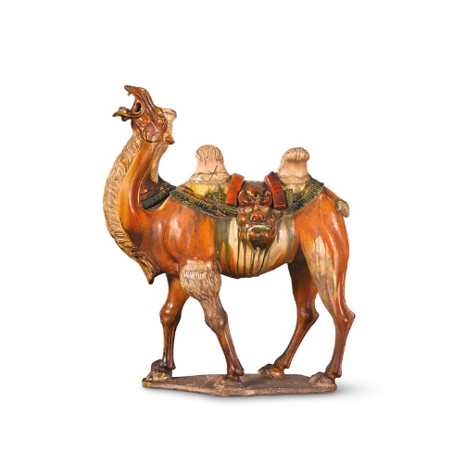

Ceramic Camel (C410)

Dog and Elephant Pedestals (29-96-328D)

Lion Statue (63-21-1)

